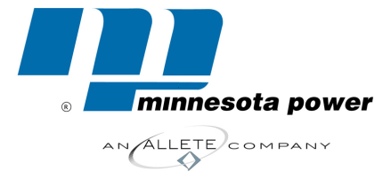

*30 west superior street / duluth, minnesota 55802-2093 / fax: 218-723-3955 /www.allete.com*

*David R. Moeller*

*Senior Attorney*

*218-723-3963*

*dmoeller@allete.com*

September 24, 2014

**VIA EMAIL**

Ms. Carol Overland

Overland Law Office/Legalectric

1110 West Avenue

Red Wing, MN 55066

**RE: RRANT Information Request**

**Docket No. E015/CN-12-1163**

Dear Ms. Overland:

Attached please find Minnesota Power’s Supplemental Response to the RRANT’s Information Request No. 2, including Attachment, in the above-referenced Docket.

Please contact me at the number above should you have any questions related to this

matter.

Yours truly,

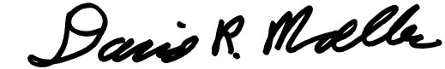

David R. Moeller

Attachments

c: Department of Commerce

Andrew Moratzka